Let's Discuss Race
(Suitable for Middle School and High School)

Discuss:
How does the Jewish tradition and community manifest and actualize its value of Tzedek, Justice, in relation to racism and related societal inequities?

Discuss:
What is the diversity within our Jewish community and how do we improve/increase education about and the engagement of all individuals within our community?

Select, Reflect and Discuss which Quote Resonates with the Current Crisis:

Do not stand idly by while your neighbor’s blood is shed.”  — Vayikra 19:16 | לֹא תַעֲמֹד עַל-דַּם רֵעֶךָ

“Injustice anywhere is a threat to justice everywhere.”
—Martin Luther King Jr.

He used to say: If I am not for myself, who is for me? But if I am for my own self [only], what am I? And if not now, when? – Pirkei Avot 1:14 | הוּא הָיָה אוֹמֵר  , אִם אֵין אֲנִי לִי, מִי לִי. וּכְשֶׁאֲנִי לְעַצְמִי, מָה אֲנִי. וְאִם לֹא עַכְשָׁיו, אֵימָתָי:

Review and Reflect:
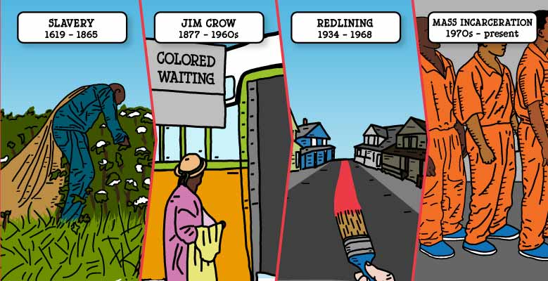
In America we celebrate the past all the time—the Declaration of Independence, the Revolutionary War, the Bill of Rights, and so much more.
The first enslaved people sold in America were brought to Jamestown, Colony of Virginia, in 1619 - almost exactly 400 years ago.

Slaves built the US Capitol. They built Wall Street. They built the White House. Slavery was an economic engine for the entire country. For more than two centuries, white Americans profited from forced Black labor. So when slavery officially came to an end in 1865, efforts to subject Black lives and communities to state control did not. Jim Crow laws, intended to maintain the prewar racial hierarchy, effectively legalized segregation in all aspects of American life for the next 100 years. It wasn’t until the 1960s, with the passage of the Voting Rights and Fair Housing acts that the Jim Crow era officially ended. The Fair Housing Act (FHA) also finally outlawed redlining, a decades-long official government policy used all across the country to effectively deny homeownership to Black Americans. In the housing boom of the 1950s, as white America began building wealth in the suburbs, Black people, by law, were deliberately and systematically shut out.

Similarly, the end of slavery didn’t stop former slaveholders from thinking of Black people as slaves. The 13th Amendment abolished slavery, but left in a loophole: “except as punishment for crime.” States throughout the former Confederacy (Texas, Arkansas, Louisiana, Tennessee, Mississippi, Alabama, Georgia, Florida, South Carolina, North Carolina and Virginia) immediately began drafting laws guaranteed to lead to the arrest of Black people, who were then put back to work (sometimes in prisons that had once been plantations.

Discuss whether this country has reckoned with slavery.

“An America that looks away is ignoring not just the sins of the past but the sins of the present and the certain sins of the future.”

Recap of the Most Recent Events:
George Floyd.
On May 25, a 46-year-old black man was killed by Minneapolis police officers. Floyd was accused by a grocery clerk of writing a bad check. Officers held him down with their knees to his neck for minutes. The police continued as Floyd lost consciousness and two other policemen watched. Floyd was heard saying “I can’t breathe” several times as bystanders begged the police to let him go but the officers refused.
Breonna Taylor.
On March 13 in Louisville, Kentucky, a 26-year-old black woman was killed in the middle of the night, in her own home by police. Breonna Taylor was an essential worker helping save lives. Three white officers broke into the wrong apartment, in the wrong neighborhood, looking to arrest a suspect they already had in custody.
Ahmaud Arbery.
On Feb. 23, a 25-year-old black man named Ahmaud Arbery was out for a run near his neighborhood in Brunswick, Georgia, when he was chased, shot and killed by two white men claiming they were making a citizen’s arrest while Arbery was simply going for a run, something most people, including myself, take for granted.
- (Suitable for Middle School and High School) Text Study:
1. Genesis 1:27  (27) And God created man in His image, in the image of God He created him; male and female He created them. | בראשית א׳:כ״ז  (כז) וַיִּבְרָ֨א אֱלֹה-ים ׀ אֶת־הָֽאָדָם֙ בְּצַלְמ֔וֹ בְּצֶ֥לֶם אֱלֹהִ֖-ים בָּרָ֣א אֹת֑וֹ זָכָ֥ר וּנְקֵבָ֖ה בָּרָ֥א אֹתָֽם׃

What is it important that we all came from one person?

2. Sanhedrin 38a

The Mishna teaches: Therefore, Adam the first man was created alone. The Sages taught in a baraita: Adam was created alone, and for what reason? So that the heretics will not say: There are many authorities in Heaven, and each created a different person. Alternatively, Adam was created alone due to the righteous and due to the wicked. It was so that the righteous will not say: We are the children of the righteous, and righteousness is natural for us, so there is no need for us to exert ourselves to be righteous, and so that the wicked will not say: We are the children of the wicked and cannot change our ways.
The baraita continues: Alternatively, he was created alone due to the families, so that the families will not quarrel with each other, each one boasting of the heritage of their progenitor. And if now that Adam was created alone, families still quarrel and each family claims superiority, if there were two people created initially, all the more so would they do this. Alternatively, he was created alone due to the robbers and due to those who take by force that which is not theirs, as the feeling of fraternity among all people, having descended from the same forefather, will limit crime. And if now that Adam was created alone, criminals still rob and take by force that which is not theirs, if there were two people created initially, all the more so would this be the case.

Consider the idea that we all came from Adam. How should this impact how we feel and behave towards other people who may not look or think like us?

3. Vayikra 19:18  (18) You shall not take vengeance or bear a grudge against your countrymen. Love your fellow as yourself: I am the LORD. | ויקרא י״ט:י״ח  (יח) לֹֽא־תִקֹּ֤ם וְלֹֽא־תִטֹּר֙ אֶת־בְּנֵ֣י עַמֶּ֔ךָ וְאָֽהַבְתָּ֥ לְרֵעֲךָ֖ כָּמ֑וֹךָ אֲנִ֖י יה'׃

How do you love you neighbor as yourself? How do you treat someone you love?

4. Mishlei 3:30  (30) Do not quarrel with a man for no cause, When he has done you no harm. | משלי ג׳:ל׳  (ל) אַל־תרוב [תָּרִ֣יב] עִם־אָדָ֣ם חִנָּ֑ם אִם־לֹ֖א גְמָלְךָ֣ רָעָֽה׃

Let's discuss harming someone (physically or emotionally) because they look or behave differently than you.

5. Bamidbar 12:1-16  (1) Miriam and Aaron spoke against Moses because of the Cushite woman he had married: “He married a Cushite woman!” (2) They said, “Has the LORD spoken only through Moses? Has God not spoken through us as well?” The LORD heard it. (3) Now Moses was a very humble man, more so than any other man on earth. (4) Suddenly the LORD called to Moses, Aaron, and Miriam, “Come out, you three, to the Tent of Meeting.” So the three of them went out. (5) The LORD came down in a pillar of cloud, stopped at the entrance of the Tent, and called out, “Aaron and Miriam!” The two of them came forward; (6) and God said, “Hear these My words: When a prophet of the LORD arises among you, I make Myself known to him in a vision, I speak with him in a dream. (7) Not so with My servant Moses; he is trusted throughout My household. (8) With him I speak mouth to mouth, plainly and not in riddles, and he beholds the likeness of the LORD. How then did you not shrink from speaking against My servant Moses!” (9) Still incensed with them, the LORD departed. (10) As the cloud withdrew from the Tent, there was Miriam stricken with snow-white scales! When Aaron turned toward Miriam, he saw that she was stricken with scales. (11) And Aaron said to Moses, “O my lord, account not to us the sin which we committed in our folly. (12) Let her not be as one dead, who emerges from his mother’s womb with half his flesh eaten away.” (13) So Moses cried out to the LORD, saying, “O God, pray heal her!” (14) But the LORD said to Moses, “If her father spat in her face, would she not bear her shame for seven days? Let her be shut out of camp for seven days, and then let her be readmitted.” (15) So Miriam was shut out of camp seven days; and the people did not march on until Miriam was readmitted. (16) After that the people set out from Hazeroth and encamped in the wilderness of Paran. | במדבר י״ב:א׳-ט״ז  (א) וַתְּדַבֵּ֨ר מִרְיָ֤ם וְאַהֲרֹן֙ בְּמֹשֶׁ֔ה עַל־אֹד֛וֹת הָאִשָּׁ֥ה הַכֻּשִׁ֖ית אֲשֶׁ֣ר לָקָ֑ח כִּֽי־אִשָּׁ֥ה כֻשִׁ֖ית לָקָֽח׃ (ב) וַיֹּאמְר֗וּ הֲרַ֤ק אַךְ־בְּמֹשֶׁה֙ דִּבֶּ֣ר ה' הֲלֹ֖א גַּם־בָּ֣נוּ דִבֵּ֑ר וַיִּשְׁמַ֖ע יְהוָֽה׃ (ג) וְהָאִ֥ישׁ מֹשֶׁ֖ה ענו [עָנָ֣יו] מְאֹ֑ד מִכֹּל֙ הָֽאָדָ֔ם אֲשֶׁ֖ר עַל־פְּנֵ֥י הָאֲדָמָֽה׃ (ס) (ד) וַיֹּ֨אמֶר ה' פִּתְאֹ֗ם אֶל־מֹשֶׁ֤ה וְאֶֽל־אַהֲרֹן֙ וְאֶל־מִרְיָ֔ם צְא֥וּ שְׁלָשְׁתְּכֶ֖ם אֶל־אֹ֣הֶל מוֹעֵ֑ד וַיֵּצְא֖וּ שְׁלָשְׁתָּֽם׃ (ה) וַיֵּ֤רֶד ה' בְּעַמּ֣וּד עָנָ֔ן וַֽיַּעֲמֹ֖ד פֶּ֣תַח הָאֹ֑הֶל וַיִּקְרָא֙ אַהֲרֹ֣ן וּמִרְיָ֔ם וַיֵּצְא֖וּ שְׁנֵיהֶֽם׃ (ו) וַיֹּ֖אמֶר שִׁמְעוּ־נָ֣א דְבָרָ֑י אִם־יִֽהְיֶה֙ נְבִ֣יאֲכֶ֔ם ה' בַּמַּרְאָה֙ אֵלָ֣יו אֶתְוַדָּ֔ע בַּחֲל֖וֹם אֲדַבֶּר־בּֽוֹ׃ (ז) לֹא־כֵ֖ן עַבְדִּ֣י מֹשֶׁ֑ה בְּכָל־בֵּיתִ֖י נֶאֱמָ֥ן הֽוּא׃ (ח) פֶּ֣ה אֶל־פֶּ֞ה אֲדַבֶּר־בּ֗וֹ וּמַרְאֶה֙ וְלֹ֣א בְחִידֹ֔ת וּתְמֻנַ֥ת יְהוָ֖ה יַבִּ֑יט וּמַדּ֙וּעַ֙ לֹ֣א יְרֵאתֶ֔ם לְדַבֵּ֖ר בְּעַבְדִּ֥י בְמֹשֶֽׁה׃ (ט) וַיִּֽחַר אַ֧ף יְהוָ֛ה בָּ֖ם וַיֵּלַֽךְ׃ (י) וְהֶעָנָ֗ן סָ֚ר מֵעַ֣ל הָאֹ֔הֶל וְהִנֵּ֥ה מִרְיָ֖ם מְצֹרַ֣עַת כַּשָּׁ֑לֶג וַיִּ֧פֶן אַהֲרֹ֛ן אֶל־מִרְיָ֖ם וְהִנֵּ֥ה מְצֹרָֽעַת׃ (יא) וַיֹּ֥אמֶר אַהֲרֹ֖ן אֶל־מֹשֶׁ֑ה בִּ֣י אֲדֹנִ֔י אַל־נָ֨א תָשֵׁ֤ת עָלֵ֙ינוּ֙ חַטָּ֔את אֲשֶׁ֥ר נוֹאַ֖לְנוּ וַאֲשֶׁ֥ר חָטָֽאנוּ׃ (יב) אַל־נָ֥א תְהִ֖י כַּמֵּ֑ת אֲשֶׁ֤ר בְּצֵאתוֹ֙ מֵרֶ֣חֶם אִמּ֔וֹ וַיֵּאָכֵ֖ל חֲצִ֥י בְשָׂרֽוֹ׃ (יג) וַיִּצְעַ֣ק מֹשֶׁ֔ה אֶל־ה' לֵאמֹ֑ר קָ֑ל נָ֛א רְפָ֥א נָ֖א לָֽהּ׃ (פ) (יד) וַיֹּ֨אמֶר ה' אֶל־מֹשֶׁ֗ה וְאָבִ֙יהָ֙ יָרֹ֤ק יָרַק֙ בְּפָנֶ֔יהָ הֲלֹ֥א תִכָּלֵ֖ם שִׁבְעַ֣ת יָמִ֑ים תִּסָּגֵ֞ר שִׁבְעַ֤ת יָמִים֙ מִח֣וּץ לַֽמַּחֲנֶ֔ה וְאַחַ֖ר תֵּאָסֵֽף׃ (טו) וַתִּסָּגֵ֥ר מִרְיָ֛ם מִח֥וּץ לַֽמַּחֲנֶ֖ה שִׁבְעַ֣ת יָמִ֑ים וְהָעָם֙ לֹ֣א נָסַ֔ע עַד־הֵאָסֵ֖ף מִרְיָֽם׃ (טז) וְאַחַ֛ר נָסְע֥וּ הָעָ֖ם מֵחֲצֵר֑וֹת וַֽיַּחֲנ֖וּ בְּמִדְבַּ֥ר פָּארָֽן׃ (פ)

How did God respond to Miriam and Aaron speaking badly about Moses' marriage to a Cushite/Black woman? Was she really Cushite? Or was Tzipporah a Midinianite?

6. Devarim 16:20  (20) Justice, justice shall you pursue, that you may thrive and occupy the land that the LORD your God is giving you. | דברים ט״ז:כ׳  (כ) צֶ֥דֶק צֶ֖דֶק תִּרְדֹּ֑ף לְמַ֤עַן תִּֽחְיֶה֙ וְיָרַשְׁתָּ֣ אֶת־הָאָ֔רֶץ אֲשֶׁר־ה' אֱלֹהֶ֖יךָ נֹתֵ֥ן לָֽךְ׃ (ס)

Is it justice to observe discrimination?
Is it justice not to pursue equality?

7. Amos 9:7  (7) To Me, O Israelites, you are Just like the Ethiopians —declares the LORD. True, I brought Israel up From the land of Egypt, But also the Philistines from Caphtor And the Arameans from Kir. | עמוס ט׳:ז׳  (ז) הֲל֣וֹא כִבְנֵי֩ כֻשִׁיִּ֨ים אַתֶּ֥ם לִ֛י בְּנֵ֥י יִשְׂרָאֵ֖ל נְאֻם־ה' הֲל֣וֹא אֶת־יִשְׂרָאֵ֗ל הֶעֱלֵ֙יתִי֙ מֵאֶ֣רֶץ מִצְרַ֔יִם וּפְלִשְׁתִּיִּ֥ים מִכַּפְתּ֖וֹר וַאֲרָ֥ם מִקִּֽיר׃

8. Abraham Joshua Heschel, Telegram to President John F. Kennedy, June 16, 1963

I look forward to privilege of being present at meeting tomorrow. Likelihood exists that Negro problem will be like the weather. Everybody talks about it but nobody does anything about it. Please demand of religious leaders personal involvement not just solemn declaration. We forfeit the right to worship God as long as we continue to humiliate Negroes. Church synagogue have failed. They must repent. Ask of religious leaders to call for national repentance and personal sacrifice. Let religious leaders donate one month's salary toward fund for Negro housing and education. I propose that you Mr. President declare state of moral emergency. A Marshall plan for aid to Negroes is becoming a necessity. The hour calls for moral grandeur and spiritual audacity.

What has changed? Was Rabbi Heschel correct?

9. Abraham Joshua Heschel, Eight Candles of Consciousness: Essays on Jewish Nonviolence (Yonassan Gershom, 2009), p. 62.
Racism is man’s gravest threat to man—-the maximum of hatred for a minimum of reason.

How do you respond?

10. Madison Grant to Charles Davenport, April 2, 1917

“It has taken us fifty years to learn that speaking English, wearing good clothes, and going to school and to church, does not transform a negro into a white man...We shall have a similar experience with the Polish Jew, whose dwarf stature, peculiar mentality, and ruthless concentration on self-interest are being engrafted upon the stock of the nation."

How does this make you feel?

11. Sanhedrin 58a: Violence

Reish Lakish says: One who raises his hand to strike another, even if he ultimately does not strike him, is called wicked, as it is stated: “And two men of the Hebrews were struggling with each other, and he said to the wicked one: Why should you strike your friend?” (Exodus 2:13). The phrase: Why did you strike, is not stated, but rather: “Why should you strike,” indicating that one who raised his hand to strike another, even if he ultimately did not strike him, is called wicked. Ze’eiri says that Rabbi Ḥanina says: One who raises his hand to strike another is called a sinner; as it is stated: “And the priest’s lad would come…and would say to him, but you shall give now, and if not, I will take by force” (I Samuel 2:15–16), and it is written with regard to this behavior: “And the sin of the youths was very great”

What does this say about an armed police officer harming an unarmed person?

12. Berakhot 10a
With regard to the statement of Rabbi Yehuda, son of Rabbi Shimon ben Pazi, that David did not say Halleluya until he saw the downfall of the wicked, the Gemara relates: There were these hooligans in Rabbi Meir’s neighborhood who caused him a great deal of anguish. Rabbi Meir prayed for God to have mercy on them, that they should die. Rabbi Meir’s wife, Berurya, said to him: What is your thinking? On what basis do you pray for the death of these hooligans? Do you base yourself on the verse, as it is written: “Let sins cease from the land” (Psalms 104:35), which you interpret to mean that the world would be better if the wicked were destroyed? But is it written, let sinners cease?” Let sins cease, is written. One should pray for an end to their transgressions, not for the demise of the transgressors themselves.

Moreover, go to the end of the verse, where it says: “And the wicked will be no more.” If, as you suggest, transgressions shall cease refers to the demise of the evildoers, how is it possible that the wicked will be no more, i.e., that they will no longer be evil? Rather, pray for God to have mercy on them, that they should repent, as if they repent, then the wicked will be no more, as they will have repented.

Rabbi Meir saw that Berurya was correct and he prayed for God to have mercy on them, and they repented.

We should pray for the wicked?
Is praying sufficient?

13. Exodus 22:20  (20) You shall not wrong a stranger or oppress him, for you were strangers in the land of Egypt. | שמות כ״ב:כ׳  (כ) וְגֵ֥ר לֹא־תוֹנֶ֖ה וְלֹ֣א תִלְחָצֶ֑נּוּ כִּֽי־גֵרִ֥ים הֱיִיתֶ֖ם בְּאֶ֥רֶץ מִצְרָֽיִם׃

Who is the stranger?
How do we, as Jews, respond?

14. Leviticus 19:18  (18) You shall not take vengeance or bear a grudge against your countrymen. Love your fellow as yourself: I am the LORD. | ויקרא י״ט:י״ח  (יח) לֹֽא־תִקֹּ֤ם וְלֹֽא־תִטֹּר֙ אֶת־בְּנֵ֣י עַמֶּ֔ךָ וְאָֽהַבְתָּ֥ לְרֵעֲךָ֖ כָּמ֑וֹךָ אֲנִ֖י ה'׃

What is vengeance or a grudge in 2020?

15. Proverbs 24:17  (17) If your enemy falls, do not exult; If he trips, let your heart not rejoice, | משלי כ״ד:י״ז  (יז) בִּנְפֹ֣ל אויביך [אֽ֭וֹיִבְךָ] אַל־תִּשְׂמָ֑ח וּ֝בִכָּשְׁל֗וֹ אַל־יָגֵ֥ל לִבֶּֽךָ׃

How should people respond when they view a senseless abuse?

16. BabylonianTalmud, Kiddushin 40b  In connection to the mishna’s statement about the importance of Torah study, the Gemara relates the following incident: And there already was an incident in which Rabbi Tarfon and the Elders were reclining in the loft of the house of Nit’za in Lod, when this question was asked of them: Is study greater or is action greater? Rabbi Tarfon answered and said: Action is greater. Rabbi Akiva answered and said: Study is greater. Everyone answered and said: Study is greater, but not as an independent value; rather, it is greater as study leads to action. | קידושין מ׳ ב:ח׳  וכבר היה רבי טרפון וזקנים מסובין בעלית בית נתזה בלוד נשאלה שאילה זו בפניהם תלמוד גדול או מעשה גדול נענה רבי טרפון ואמר מעשה גדול נענה ר"ע ואמר תלמוד גדול נענו כולם ואמרו תלמוד גדול שהתלמוד מביא לידי מעשה

Which Rabbi (Tarfon or Akiva) do you agree with? Why?
What "action" is being discussed here?
What kind of study is important for social justice? Why?
In your experience, does study really lead to action? If so, how?

17. Pirkei Avot 4:1  Ben Zoma says:.Who is the mighty one? One who overpowers one's inclination, as it says, "slowness to anger is better than a mighty person and the ruler of one's own spirit than the conqueror of a city." (Mishlei 16:32). | משנה אבות ד׳:א׳  בֶּן זוֹמָא אוֹמֵר...אֵיזֶהוּ גִבּוֹר, הַכּוֹבֵשׁ אֶת יִצְרוֹ, שֶׁנֶּאֱמַר (משלי טז) טוֹב אֶרֶךְ אַפַּיִם מִגִּבּוֹר וּמשֵׁל בְּרוּחוֹ מִלֹּכֵד עִיר

As Jews, how should we respond to senseless killing?
How does a video recording provide us with important information?
Darnella Frazier, 17, bravely filmed former officer Derek Chauvin kneeling on Floyd's neck in Minneapolis but has been slammed by online bullies.
What would you have done?

18. Sanhedrin 72a:15-16  ...if it is as clear to you as the sun that the thief is not at peace with you, then kill them. But if it is not, do not kill them. | סנהדרין ע״ב א:ט״ו-ט״ז  ת"ר: (שמות כב, א) אין לו דמים אם זרחה השמש עליו וכי השמש עליו בלבד זרחה אלא אם ברור לך הדבר כשמש שאין לו שלום עמך הרגהו ואם לאו אל תהרגהו.  תניא אידך: אם זרחה השמש עליו דמים לו וכי השמש עליו בלבד זרחה אלא אם ברור לך כשמש שיש לו שלום עמך אל תהרגהו ואם לאו הרגהו

How does this text resonate with the riots that have followed the murder?

19. Shmot 2:11-12  (11) Sometime after that, when Moses had grown up, he went out to his kinsfolk and witnessed their labors. He saw an Egyptian beating a Hebrew, one of his kinsmen. (12) He turned this way and that and, seeing no one about, he struck down the Egyptian and hid him in the sand. | שמות ב׳:י״א-י״ב  (יא) וַיְהִ֣י ׀ בַּיָּמִ֣ים הָהֵ֗ם וַיִּגְדַּ֤ל מֹשֶׁה֙ וַיֵּצֵ֣א אֶל־אֶחָ֔יו וַיַּ֖רְא בְּסִבְלֹתָ֑ם וַיַּרְא֙ אִ֣ישׁ מִצְרִ֔י מַכֶּ֥ה אִישׁ־עִבְרִ֖י מֵאֶחָֽיו׃ (יב) וַיִּ֤פֶן כֹּה֙ וָכֹ֔ה וַיַּ֖רְא כִּ֣י אֵ֣ין אִ֑ישׁ וַיַּךְ֙ אֶת־הַמִּצְרִ֔י וַֽיִּטְמְנֵ֖הוּ בַּחֽוֹל׃

20. Devarim 25:17-19  (17) Remember what Amalek did to you on your journey, after you left Egypt— (18) how, undeterred by fear of God, he surprised you on the march, when you were famished and weary, and cut down all the stragglers in your rear. (19) Therefore, when the LORD your God grants you safety from all your enemies around you, in the land that the LORD your God is giving you as a hereditary portion, you shall blot out the memory of Amalek from under heaven. Do not forget! | דברים כ״ה:י״ז-י״ט  (יז) זָכ֕וֹר אֵ֛ת אֲשֶׁר־עָשָׂ֥ה לְךָ֖ עֲמָלֵ֑ק בַּדֶּ֖רֶךְ בְּצֵאתְכֶ֥ם מִמִּצְרָֽיִם׃ (יח) אֲשֶׁ֨ר קָֽרְךָ֜ בַּדֶּ֗רֶךְ וַיְזַנֵּ֤ב בְּךָ֙ כָּל־הַנֶּחֱשָׁלִ֣ים אַֽחַרֶ֔יךָ וְאַתָּ֖ה עָיֵ֣ף וְיָגֵ֑עַ וְלֹ֥א יָרֵ֖א אֱלֹהִֽ-ים׃ (יט) וְהָיָ֡ה בְּהָנִ֣יחַ ה'ָ אֱלֹהֶ֣יךָ ׀ לְ֠ךָ מִכָּל־אֹ֨יְבֶ֜יךָ מִסָּבִ֗יב בָּאָ֙רֶץ֙ אֲשֶׁ֣ר יה'־אֱ֠לֹהֶיךָ נֹתֵ֨ן לְךָ֤ נַחֲלָה֙ לְרִשְׁתָּ֔הּ תִּמְחֶה֙ אֶת־זֵ֣כֶר עֲמָלֵ֔ק מִתַּ֖חַת הַשָּׁמָ֑יִם לֹ֖א תִּשְׁכָּֽח׃ פ

21. "...Rabbi Chaim Soleveitchik of Brisk...was said to have declared that the commandment to destroy Amalek extends to all who embrace the ideology of Amalek and seek to annihilate the Jewish nation. Rabbi Bleich also notes that Rabbi Judah Loew of Prague remarked that all enemies of Israel throughout the generations of dispersion are in fact genealogical descendants of Amalek....Therefore, by viewing the commandment to destroy Amalek as one that requires the Jewish people to engage in warfare against all who seek to annihilate Israel, and because biblically commanded wars are obligatory, Israel would have Halachic sanction to engage in a war against Amalek or those who hold the same views as the people of Amalek."
("Does Ariel Sharon Consult His Rabbi? How Israeli Responses To Terrorism Are Justified Under Jewish Law" David Rosen, 2003)

22. Yad VaShem, the Holocaust museum in Jerusalem. Both in our prayer book and on that wall it reads, “Forgetfulness leads to exile; while remembrance is the secret of redemption.” These are words spoken by the great rabbi, the holy Baal Shem Tov.

How is it that memory can bring about a better world? There is a story of a rabbi, Rabbi Zvi Elimelech, who in the middle of the celebration of Purim suddenly ceased the festivities and turned to his students and said, “Prepare the carriages, it is time for us to fulfill the commandment that appears at the end of the megillah. It is time to blot out Amalek!”

The students were scared. They did not understand, but, trusting their rabbi, they prepared the carriages, got in, and took off into the night. The rabbi had the carriages drive down to the nearest inn which was filled with cossacks who were well into their nightly drinking. The rabbi got out of the carriage and strode into the inn, his students cowering behind him. As he walked in, he looked around and picked out the biggest cossack, the one who was obviously in charge, and walked right over to him.
The rabbi stuck out his hand, palm up, and asked the Cossack to dance. There was a silence that swept the room before the Cossack slapped his hand down into the rabbi’s waiting palm and they began to dance wildly throughout the room. The students all went and found their own Cossack partners and soon everyone was tearing up the dance floor.

At the end of the song, the rabbi turns to his partner and says, “I heard that there is a pogrom planned for tomorrow.” The Cossack looked sheepishly at the floor and grumbled in affirmation. The rabbi said, “There will be no pogrom tomorrow.” The Cossacks face brightened and they began to dance again in agreement, hugging and kissing. Needless to say, many drinks were shared as they all danced into the night.

In a moment like this, we must look back at the far too common plague of anti-Semitism that has been written into far too many pages of our Jewish history. We must remember the likes of Amalek, of Haman, and of Hitler who tried to wipe us from the face of the Earth. And in remembering, we must remember what our rabbis have taught us: to destroy our enemies through dance, through coming together.

How do the texts above and this story resonate with the current events?

Select a text from the ones that follow. Select one which reflects the Jewish relationships with others in our country.

23. At the Passover seder and said the words:  This promise has stayed by our ancestors and us,  For it was not one alone that stood upon us to destroy us,  Rather, in every generation they stand upon us to destroy us,  And The Holy Blessed One saves us from their hand. | וְהִיא שֶׁעָמְדָה לַאֲבוֹתֵינוּ וְלָנוּ  שֶׁלֹּא אֶחָד בִּלְבָד עָמַד עָלֵינוּ לְכַלּוֹתֵנוּ  אֶלָּא שֶׁבְּכָל דּוֹר וָדוֹר עוֹמְדִים עָלֵינוּ לְכַלּוֹתֵנוּ  וְהַקָּדוֹשׁ בָּרוּךְ הוּא מַצִּילֵנוּ מִיָּדָם

24. Exodus 12:38  (38) Moreover, a mixed multitude went up with them, and very much livestock, both flocks and herds. | שמות י״ב:ל״ח  (לח) וְגַם־עֵ֥רֶב רַ֖ב עָלָ֣ה אִתָּ֑ם וְצֹ֣אן וּבָקָ֔ר מִקְנֶ֖ה כָּבֵ֥ד מְאֹֽד

25. Exodus 12:49  (49) There shall be one law for the citizen and for the stranger who dwells among you. | שמות י״ב:מ״ט  (מט) תּוֹרָ֣ה אַחַ֔ת יִהְיֶ֖ה לָֽאֶזְרָ֑ח וְלַגֵּ֖ר הַגָּ֥ר בְּתוֹכְכֶֽם׃

26. Exodus 23:9  You shall not oppress a stranger, for you know the feelings of the stranger, having yourselves been strangers in the land of Egypt. | שמות כ״ג:ט׳  (ט) וְגֵ֖ר לֹ֣א תִלְחָ֑ץ וְאַתֶּ֗ם יְדַעְתֶּם֙ אֶת־נֶ֣פֶשׁ הַגֵּ֔ר כִּֽי־גֵרִ֥ים הֱיִיתֶ֖ם בְּאֶ֥רֶץ מִצְרָֽיִם׃

27. Isaiah 56:7  (7)...For My House shall be called A house of prayer for all peoples.” | ישעיהו נ״ו:ז׳  (ז) ... כִּ֣י בֵיתִ֔י בֵּית־תְּפִלָּ֥ה יִקָּרֵ֖א לְכָל־הָעַמִּֽים׃

28. Talmud Bavli Bava Metzia 59b
What is the meaning of that which is written: “And you shall not mistreat a convert nor oppress him, because you were strangers in the land of Egypt” (Shmot 22:20)? We learned that Rabbi Natan says: A defect that is in you, do not mention it in another. Since the Jewish people were themselves strangers, they are not in a position to demean a convert because he is a stranger in their midst.

29. Leviticus 19:18  (18) Love your fellow as yourself | ויקרא י״ט:י״ח  (יח)... וְאָֽהַבְתָּ֥ לְרֵעֲךָ֖ כָּמ֑וֹךָ

30. Ramban on Leviticus 19:18
The phrase “Love your neighbor as yourself” cannot be meant literally, since man cannot be expected to love his neighbor as himself. Moreover, Rabbi Akiva has ruled that “Your life comes first.” The Torah here enjoins us that we should wish upon our neighbor the same benefits that we wish upon ourselves. Perhaps, this is the reason for the dative instead of the accusative form of the verb phrase; we find the same in “And you shall love him as yourself” (19:34). Indeed, sometimes a person may wish upon his neighbor certain benefits, but only wealth, not wisdom and the like. But even if he wishes his cherished friend well in everything, i.e. wealth, honor, learning, and wisdom, he will not do so unstintingly; he will still insist on a larger share of the benefits. It is this shortcoming that the Torah condemned. Rather, a man should wish his fellow well in everything, just as he does in his own case, and he should place no limitations on his love. Therefore, in the case of Yonatan and David (I Shemuel 20:17), it says that Yonatan “loved him as his own soul,” since he had removed all jealousy from his heart, declaring “And you shall rule over Israel” (ibid. 23:17).

31. Mishneh Torah, Human Dispositions 6:3  (3) It is mandatory upon every man to love each and every one of Israel even as he loves his own self, for it is said: "But thou shalt love thy neighbor as thyself" (Lev. 19.19.). One is therefore, obliged to speak in praise of his neighbor, and to be considerate of his money, even as he is considerate of his own money, or desires to preserve his own honor. "But whosoever glorifies himself in disgracing his neighbor has no share in the world to come" (Yerushalmi, Hegigah. 2.1).³Cairo quotes Pirke Abot, chapter 2, as authority for this; but the error evidently was made by copyist. G. | משנה תורה, הלכות דעות ו׳:ג׳  (ג) מִצְוָה עַל כָּל אָדָם לֶאֱהֹב אֶת כָּל אֶחָד וְאֶחָד מִיִּשְׂרָאֵל כְּגוּפוֹ שֶׁנֶּאֱמַר (ויקרא יט יח) "וְאָהַבְתָּ לְרֵעֲךָ כָּמוֹךָ". לְפִיכָךְ צָרִיךְ לְסַפֵּר בְּשִׁבְחוֹ וְלָחוּס עַל מָמוֹנוֹ כַּאֲשֶׁר הוּא חָס עַל מָמוֹן עַצְמוֹ וְרוֹצֶה בִּכְבוֹד עַצְמוֹ. וְהַמִּתְכַּבֵּד בִּקְלוֹן חֲבֵרוֹ אֵין לוֹ חֵלֶק לָעוֹלָם הַבָּא:

32. Mishneh Torah, Human Dispositions 6:4  (4) The love for the proselyte, who came and embraced the protection beneath the wings of the Shekinah, rests upon two mandatory commandments, one because he is included in the commandment concerning a neighbor, and the other because he is a stranger, and the Torah charged us, saying: "Love ye therefore the stranger" (Deut. 10.19.). He commanded on the love for the stranger as He commanded concerning the love for Himself, saying: "And thou shalt love the Lord thy God" (Ibid. 6.5.). The Holy One, blessed is He! loves the strangers Himself, even as it is said: "And (He) loveth the stranger" (Ibid. 10.18).⁴Baba Mezi’a, 59b. G. | משנה תורה, הלכות דעות ו׳:ד׳  (ד) אַהֲבַת הַגֵּר שֶׁבָּא וְנִכְנָס תַּחַת כַּנְפֵי הַשְּׁכִינָה שְׁתֵּי מִצְוֹת עֲשֵׂה. אַחַת מִפְּנֵי שֶׁהוּא בִּכְלַל רֵעִים וְאַחַת מִפְּנֵי שֶׁהוּא גֵּר וְהַתּוֹרָה אָמְרָה (דברים י יט) "וַאֲהַבְתֶּם אֶת הַגֵּר". צִוָּה עַל אַהֲבַת הַגֵּר כְּמוֹ שֶׁצִּוָּה עַל אַהֲבַת עַצְמוֹ שֶׁנֶּאֱמַר (דברים ו ה) "וְאָהַבְתָּ אֵת ה' אֱלֹהֶיךָ". הַקָּדוֹשׁ בָּרוּךְ הוּא עַצְמוֹ אוֹהֵב גֵּרִים שֶׁנֶּאֱמַר (דברים י יח) "וְאֹהֵב גֵּר":

33. ​"Kansas City Rabbi Clocks Neo-Nazi In Airport"
By Daniel Sieradski, JewSchool.com, 4/19/05
Rabbi David Fine, the rabbi of an Orthodox congregation in Oberland Park, Kansas — who is not exactly known for being a “tough” man — found himself in an altercation with a neo-Nazi earlier today at the Kansas City International airport. After a brief shouting match, the rav tossed a cup of coffee in the person’s face and gave him a punch before an all-out brawl ensued.

- (Suitable for Middle School and High School) Share a story:
Break groups into pair/small groups.
Encourage each group to take a picture
Have each group create/imagine and share a story about the picture.
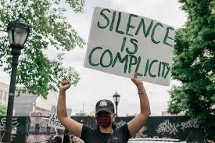

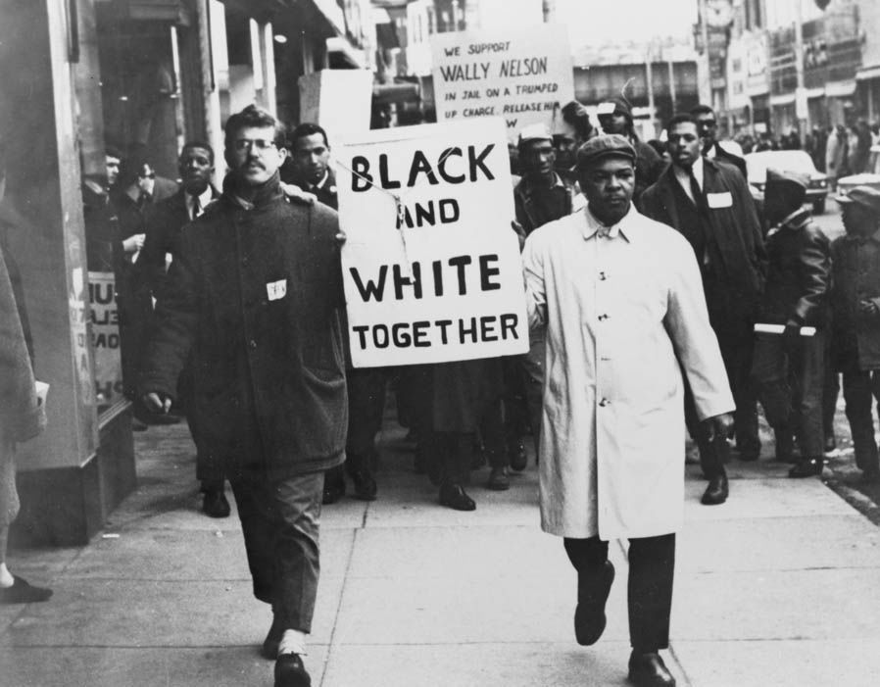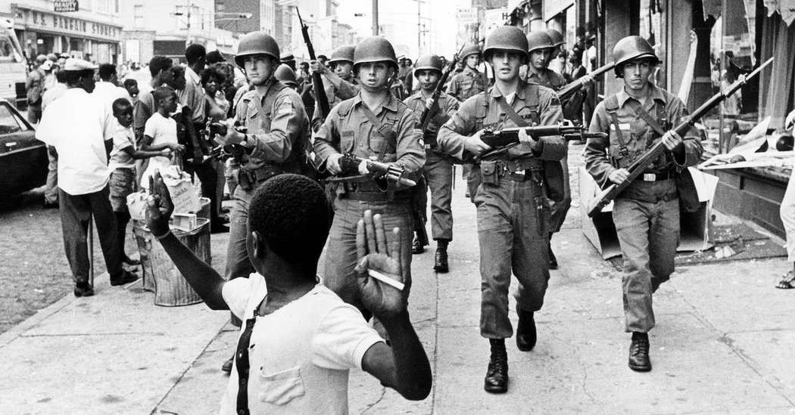

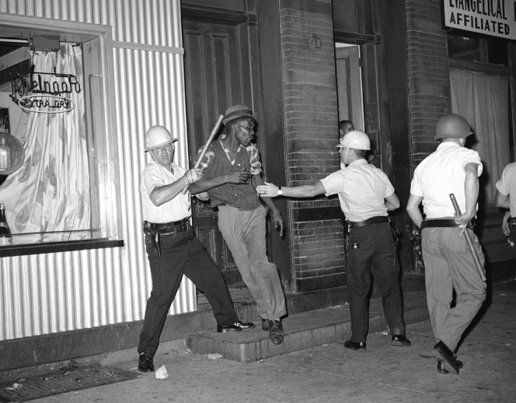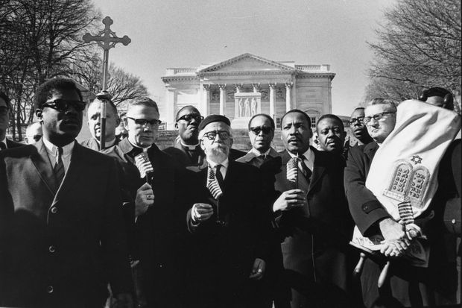

- (Elementary School and Up) Who are you? (Remind everyone to be polite and respectful)
Encourage students to SEE you.
Go around a circle and have each student describe the person to the left of them:
What do they know about you? What don’t they know about you?
What are the things that make you unique and different from other people?
What are the things that make you the same?
What are the parts of your identity you are most grateful for?
Is skin color a part of your story?
What story does the color of your skin tell about your ethnic or racial identities?
Why is race important?
Does it define you? If so, why? If not, why not?

- (Elementary School and Up) Read Aloud!
Children's books are one of the most effective tools to engage with young children on important issues. To encourage conversations about race and diversity with your children, check out this list of books to read together as a family.
Sulwe: Lupita Nyong's (Author) and Vashti Harrison (Illustrator)
This Coretta Scott King award-winning picture book is about self-esteem and beauty within. It’s a whimsical and heartwarming story about a little girl who learns to embrace her unique self.
Whose Knees Are These? Jabari Asim (Author) and LeUyen Pham (Illustrator)
This interactive and multicultural board book is a fun way to embrace diversity through a baby’s dimpled knees

Hair Love: Matthew A. Cherry (Author) and Vashti Harrison (Illustrator)
This sweet story is about a little girl with beautiful hair. When her dad has to help style it for a special occasion, he has a lot to learn, but is ready for the challenge since he loves his daughter so much.

The Day You Begin
Jacqueline Woodson (Author) and Rafael López (Illustrator)
National Book Award winner Jacqueline Woodson and two-time Pura Belpré Illustrator Award winner Rafael López bring this inspiring story to life about finding the courage to connect. It’s about how sometimes you can feel like an outsider, but sharing our stories can bring us together.

I Believe I Can
Grace Byers (Author) and Keturah A. Bobo (Illustrator)
This gorgeously illustrated book lets all kids know that, no matter their background, they can love and believe in themselves.

Little Leaders: Bold Black Women in History
Vashti Harrison
Through sweet illustrations and educational text, the biographies of 40 remarkable Black women are brought to life. Scientists, artists and activists from history are all included in this inspiring book.

My Hair is a Garden
Cozbi A. Cabrera
When Mack gets teased and taunted at school about her unruly hair, she turns to her neighbor Miss Tillie for comfort and help. To help Mack learn to care for her hair — and appreciate herself — Miss Tillie uses the metaphor of her lush garden to show Mack the many kinds of beauty and all the nurturing they require.

Amazing Grace
Mary Hoffman
Grace loves to act, but one day some kids tell her she can’t play the part of Peter Pan because of the way she looks. Grace’s grandmother helps this young girl realize that with effort anything can be achieved. It's an inspiring and heartwarming story.

I Am Enough
Grace Byers
This ode to female empowerment is the perfect gift for any little girl in your life. It’s all about loving who you are, kindness, and respecting others.

All Are Welcome
Alexandra Penfold (Author) and Suzanne Kaufman (Illustrator)
This picture book celebrates diversity by showing how children in one classroom all grow and learn from each other’s traditions.

Mufaro's Beautiful Daughters: An African Tale
John Steptoe
This Caldecott Award winning book is inspired by a traditional African folktale that is a classic Cinderella story. It also introduces children to the history and culture of Zimbabwe.

She Persisted: 13 Women Who Changed the World
Chelsea Clinton (Author) and Alexandra Boiger (Illustrator)
This book features 13 women throughout history and today who persevered in the face of adversity. It encourages your child to keep striving for your dreams and to speak up.

The Barefoot Book of Children
Kate DePalma and Tessa Strickland
This narrative nonfiction book shows diversity and encourages children to appreciate our differences. Created with the guidance of diversity experts, it empowers children to ask questions and learn about children around the globe.

- (Suitable for Middle School and High School) Take a stand:
- Peacefully protest
- Email and call your government representatives
- Donate to grassroots organizations – whatever form is meaningful to you
- Create a fundraiser
- Check in, Reach out to some of your friends, neighbors, or families are Black and Brown. Reach out to them
- Reach out to peer Black and Brown institutions.
- Encourage your synagogue, school, or youth group to reach out to churches, and ask if they need support with a donation, medical supplies, or by remotely attending any racial justice programs.
- Amplify their messages in your social media and lists.
- Listen to marginalized voices in your own organization, and respond to their needs.
- Encourage a living wage to every person in your midst.
- Ask every person a name and talk to them: A custodian, a cook.
- While you’re doing this work in your organization, continue to develop your antiracist muscles – have a small circle or hevrusa of colleagues and thought partners with whom you can think through challenges and who can push you.
- Lead by example.
- If you can attend a protest, do so
- Help buy supplies for protestors and figure out how to get them to someone who’s attending.

- (Suitable for Middle School and High School) Where Do You Stand?
This teaching strategy helps students share their opinions by lining up along a continuum to represent their point of view.
- Post a statement and then, at the other end of the line, post its opposite. (ex. rename confederate army bases, Jews played an important role in advancing the civil rights of, and furthering opportunities for, African Americans, whose fate Jews considered intertwined with their own as fellow minorities in a WASP-dominated country, etc.)
- Reiterate your class rules about respect for the opinions and voices of others and call for them to be honest, but not insulting. Readdress ways to constructively disagree with one another, and require that when offering their opinion or defense of their stance if they stand on either extreme, they are absolute in their agreement or disagreement.
- They may also stand anywhere in between the two extremes, depending on how much they do or do not agree with the statement.
- Explain positions
- Once students have lined up, ask them to explain why they have chosen to stand where they are. Encourage students to refer to evidence and examples when defending their stance.
- It is probably best to alternate from one end to the middle to the other end, rather than allowing too many voices from one stance to dominate.
- After about three or four viewpoints are heard, ask if anyone wishes to move.
- Encourage students to keep an open mind; they are allowed to move if someone presents an argument that alters where they want to stand on the line.
- Run the activity until you feel that most or all voices have been heard, making sure that one person does not dominate.
- Debriefing There are many ways to debrief this exercise.
- Reflect in their journals about how the activity changed or reinforced their original opinion.
- Brainstorm ways to support your position through chesed or mitzvot.

- (Suitable for Middle School and High School) Four Corners Debate:
- Preparation Label the four corners of the room with signs reading: “strongly agree,” “agree,” “disagree,” “strongly disagree.”
- Generate a list of controversial statements related to the material being studied. Statements most likely to encourage discussion typically do not have one correct or obvious answer, elicit nuanced arguments (e.g., “This might be a good idea some of the time, but not all of the time”), and represent respected values on both sides of the debate.
- Introduce statements
- Ask students to move to the corner of the room that best represents their opinion. Once students are in their places, ask for volunteers to justify their position.
- 5. Encourage students to switch corners if someone presents an idea that causes a change of mind.
- Reflection

- (Suitable for Middle School and High School) Safe Spaces:
- The following activity is designed to help create a safe space. You can replace the word “race” with whatever sensitive topic you’re focused on.
- Have students take several minutes to complete this sentence: “I mostly feel ______________ when discussing race, because ______________.”
- Now that students have gathered their thoughts, tell them that you are going to do a group brainstorm.
- They should not make “I” statements or share how they feel or what they wrote. Tell students: Let’s put words on the board that represent the feelings that we think may be in the room when we discuss race. At this point, we will just list and not comment on them.
- Now look at the list. Ask students: What do the words have in common? (Usually the words are mostly, but maybe not all, negative.) What else do you notice? (The words are not just surface observations; they are deeply personal feelings.) Do you have any other important reflections? (The words represent a wide and varied range of responses.) Which of these feelings are most valid? (They are all valid. You may want to acknowledge that this is a rhetorical question, but it is important to validate everyone’s feelings.) Where do these feelings come from? (Personal experiences, the media, stereotypes, etc.)
- It’s important to acknowledge that these feelings are in the room and that they need not be afraid of them. Each person should be allowed to enter this conversation wherever he or she is without being judged or shut down. Everyone needs to feel free to participate without fear of being called racist or given any other label. Sometimes it is helpful to first acknowledge the possible discomfort of participants.

- (Suitable for Middle School and High School) Big Paper Building a Silent Conversation:
- Use questions, quotations, historical documents, and excerpts from novels, poetry, or images. Groups can be given the same stimulus for discussion; however more often, they are given different texts related to the same theme.
- This activity works best when students are working in pairs or triads. Make sure that all students have a pen or marker. Some teachers have students use different colors to make it easier to see the back-and forth flow of a conversation.
- Each group also needs a “big paper” (typically a sheet of poster paper) that can fit a written conversation and added comments.
- In the middle of the page, tape or write the “stimulus” (image, quotation, excerpt, etc.) that will be used to spark the students’ discussion.
- The importance of silence
- Inform the class that this activity is completed in silence and all communication is done in writing.
- Tell students that they will have time to speak in pairs and in large groups later.
- Before the activity begins, go over all of the instructions and ask students if they have questions. This will avoid questions during the activity and minimize the chance that students will interrupt the silence once it has begun. You can also remind students of their task as they begin each new step.
- Comment on your Big Paper Each group receives a Big Paper; each student receives a marker or pen.
- The groups read the text in silence.
- After students have finished, they may comment on the text and ask questions of each other in writing on the Big Paper. The written conversation must start on the text but can stray to wherever the students take it. If someone in the group writes a question, another member should address it by writing on the Big Paper.
- Students can draw lines connecting a comment to a particular question. Make sure students know that more than one of them can write on the Big Paper at the same time.
- It should be at least 15 minutes.
- Ask the students to leave their partner(s) and walk around reading the other Big Papers.
- Students bring their marker or pen and can write comments or further questions for thought on other Big Papers.
- Return to your own Big Paper The silence is broken.
- Encuorage students to review any comments written by others.
- Now they can have a free, verbal conversation about the text, their own comments, what they read on other papers, and comments that their fellow students wrote back to them.
- The conversation can begin with a simple prompt such as, “What did you learn from doing this activity?”
- Brainstorm next steps in your goal of tikkun olam and chesed.

- (Suitable for Middle School and High School) Save the Last Word for me
- Identify a reading or video excerpt that will serve as the catalyst for this activity.
- Have students read or view the selected text (consider one of the sources provided earlier).
- Ask students to highlight three sentences that particularly stand out for them and to write each sentence on the front of an index card. On the back, they should write a few sentences explaining why they have chosen that quote—what it means to them, reminds them of, etc. They may connect it to something that has happened to them in their own life, to a film or book they saw or read, or to something that has happened in history or is happening in current events.
- Divide into groups of three, labeling one student A, one B, and the other C. Invite student A to read one of her chosen quotations and talk about why she chose it. Give the student a set amount of time, perhaps a minute, to speak.
- During that minute, Students B and C listen; they do not interrupt or interject.
- After the minute, Student B gets a chance to speak for one minute. He can both expand on Student A’s thinking, say what questions it raised for him, provide a different idea, or challenge the thinking of Student A. When Student B talks, Students A and C listen; they do not interrupt or clarify. After Student B has a minute, Student C gets a turn to speak without interruption. Finally, Student A gets one minute to answer questions or respond to the other students’ ideas. In this way, Student A gets the “last word.”
- (The intent of this exercise is to create equity in a discussion and for students to practice moments of listening without trying to immediately respond. Each student should get a chance to start a round of conversation with the quote or phrase they pulled from the text and have the “last word.”
- After each student has had a turn, you may want to open up the class to a larger, freeform discussion in order to process all the structured discussions.
- Discuss ways to implement mitzvah projects or change reflecting the text chosen.

